“PROCEDURE AND STEPS OF EXECUTION OF THE MULTI-PLAYER GAME PROJECT:”

STEP 1) As, all the source code script files are compiled successfully using the “make” command, so, the first step starts with simply running the Server with ”./server” command in the terminal.

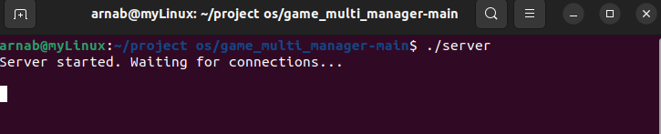

STEP 2) Now, it is the turn of the client to connect to the Server and work out with the game mechanism. It is done by simply executing the “./client” command in an another terminal window separately.

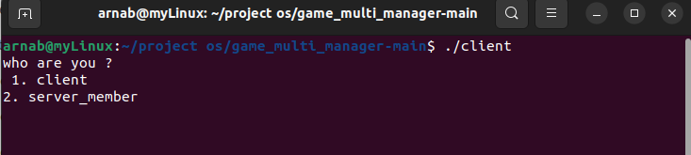

STEP 3) The user can login either as a client member or a server member here.

# But, here, I am covering only the functionalities of the client member side.

STEP 3) After this, the user has to provide the terminal with his/her login credentials i.e., the username and password. Both the details get validated and authenticated with the actual original credentials stored at the server database.

## If the authentication fails due to mismatched details, the client portal gets stopped automatically and the closing of the client connection also gets signaled at the server side.

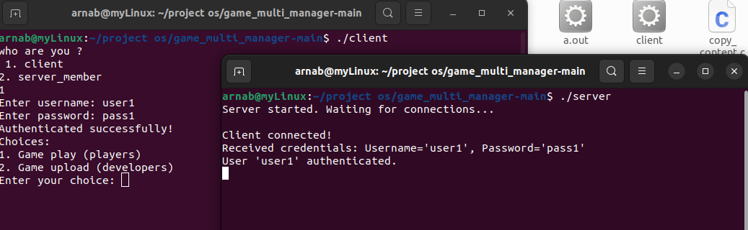

STEP 4) with the success of the authorization and verification, the user client is prompted with two options 1) play game (for players ) and 2) upload game(for developers).

## Users can choose the first one to play and execute the game, whereas, users can also upload any game source code file in C language through the second option.

STEP 5) The game play begins with simply printing a string buffer on the output window after taking input from the user like, “ Echo: <string> “.

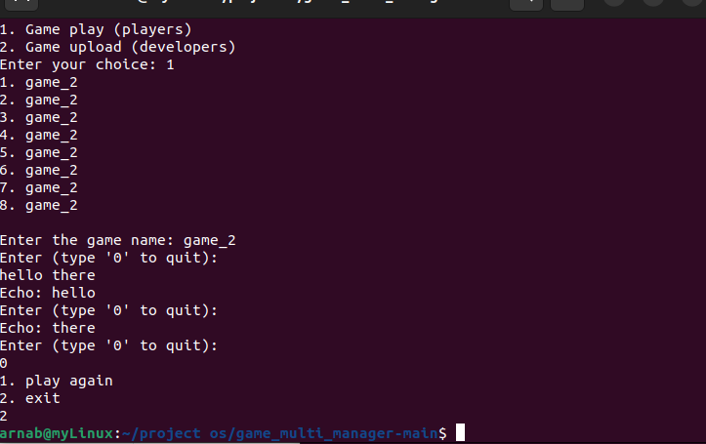

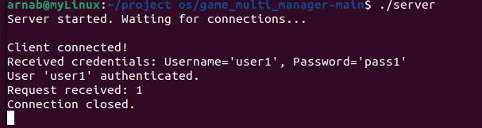

## Covering, the functionalities of the sever member side on the client side terminal window.

STEP 1) On signing in as a sever member , the user again has to provide his/her login credentials for full-fledged interaction with the server.

STEP 2) After the successful validation, the user is prompted with 4 distinct options.

The functionalities have been displayed in the snapshots below accordingly.

